**Functional Requirements Document (FRD)**

**Project: Price Aware**

**Prepared by: Tejashwini Patil (09)**

**Shreya Wallalwar (25)**

**1. Project Overview**

**Project Name:** Price Aware

**Project**

**Description:**  
Price Aware is a web-based platform designed for common and regular travellers, including students and office employees, to help them stay informed about transportation costs within a city. The website provides users with a detailed price range for traveling between different areas by various modes of transport, such as auto-rickshaws, city buses, and taxis. Additionally, it includes maps to help users track their location and navigate their routes. The website also features blogs and reviews where users can share their experiences and insights.

**Purpose:**  
The main purpose of the Price Aware website is to empower users with knowledge about transportation fares, provide location tracking via maps, and offer a platform for sharing experiences through blogs and reviews. This enables users to make informed decisions, avoid being overcharged, and benefit from the experiences of others.

**Scope:**  
The website will cover transportation fares across various cities and offer features for viewing, searching, and comparing prices for different modes of transport from one area to another within a city. The integration of maps will further assist users in navigating and understanding their routes. Additionally, users can contribute to the platform by writing blogs and reviews based on their travel experiences.

**2. Functional Requirements**

**2.1 User Interface (UI) Requirements**

* **Homepage:**
  + A clean and intuitive homepage that introduces the purpose of the website.
  + A search bar allowing users to select or input the city they are interested in.
  + Navigation menu with links to key sections: "About," "Cities," "Blogs & Reviews," "Contact," and "FAQs."
* **City Selection:**
  + Users should be able to select a city from a dropdown list or by typing in the search bar.
  + Upon selection, the website should display the modes of transport available in that city (auto, bus, taxi).
* **Fare Lookup:**
  + Users should be able to select the start and end points within a city (e.g., neighbourhoods or landmarks).
  + The system should display a price range for each available mode of transport.
* **Compare Prices:**
  + Users should be able to compare prices across different modes of transport.
  + The comparison should show minimum, average, and maximum fare estimates.
* **Maps Integration:**
  + The website should include interactive maps that allow users to view their current location, select start and end points, and visualize their route.
  + The maps should also display fare estimates based on the selected route and transport mode.
* **Blogs & Reviews:**
  + A dedicated section where users can read, write, and comment on blogs and reviews about their travel experiences.
  + Users should be able to rate and review transportation services within different cities.
  + Blogs should be categorized by city, mode of transport, and other relevant tags for easy navigation.
* **Responsive Design:**
  + The website should be fully responsive, providing an optimal experience across desktops, tablets, and mobile devices.

**2.2 Functional Requirements**

* **City and Transport Data Management:**
  + The system should store fare data for multiple cities.
  + Admins should be able to add, update, or delete city-specific transportation fare data.
  + The system should account for fare variations based on distance, time of day, and traffic conditions.
* **Search and Filter:**
  + Users should be able to search for fare estimates based on specific criteria like distance, time, and mode of transport.
  + Filtering options should include transport mode, city, and time of travel.
* **Maps and Location Tracking:**
  + Users should have access to maps that help them track their current location.
  + The maps should allow users to set their starting and destination points to calculate fare estimates and route options.
  + The system should update the user's location in real-time, providing accurate and relevant information.
* **Blogs & Reviews:**
  + Users should be able to write and publish blogs and reviews about their experiences with transportation services.
  + The system should allow users to upload images, videos, and other media to enrich their posts.
  + Users can comment on and rate blogs and reviews, fostering community interaction.
* **User Accounts:**
  + Users can create accounts to save their favourite cities or routes for quick access in the future.
  + Users should receive notifications about fare updates, new blogs, or reviews in their selected cities.
* **Localization:**
  + The website should support multiple languages, with the ability to add or remove languages as needed.

**2.3 Security Requirements**

* **Data Protection:**
  + User data, including saved routes, preferences, and blog/review content, should be stored securely.
  + Implement SSL for secure data transmission.
* **Authentication:**
  + User login and registration processes should be secure, with password protection and encryption.
  + Admins should have a separate, secure login for managing city and fare data, as well as blog content.

**2.4 Performance Requirements**

* **Scalability:**
  + The website should be able to handle a large number of users simultaneously, especially during peak travel hours.
  + The system should efficiently manage and query large datasets of fare information and user-generated content.
* **Load Time:**
  + The website should load within 3 seconds on an average internet connection.
  + Optimize images, scripts, maps, and user-generated content to ensure fast loading times.

**2.5 Usability Requirements**

* **User-Friendly Interface:**
  + The website should be intuitive, with a focus on ease of use for non-technical users, such as students and office employees.
  + Provide tooltips and help sections for any complex features.
* **Accessibility:**
  + The website should be accessible to users with disabilities, following guidelines.
  + Implement features such as keyboard navigation and screen reader support.

**2.6 Integration Requirements**

* **API Integration:**
  + Integrate with external APIs to fetch real-time traffic and map data, which might influence fare estimates and route calculations.
* **Data Import/Export:**
  + Admins should be able to import and export fare data in CSV or Excel format.

**2.7 Maintenance Requirements**

* **Content Management System (CMS):**
  + The website should be built on a CMS that allows easy content updates without needing extensive technical knowledge.
  + Regular updates to fare data and user-generated content should be made easy through the CMS.
* **Backup and Recovery:**
  + Implement regular backups of the website data to ensure quick recovery in case of data loss.

**3. Non-Functional Requirements**

**3.1 Performance**

* The website should be able to handle 1,000 concurrent users with response times under 3 seconds.

**3.2 Reliability**

* The system should have an uptime of 99.9% to ensure constant availability for users.

**3.3 Security**

* Regular security audits should be conducted to ensure data protection.

**4. Assumptions**

* The fare data is assumed to be accurate and regularly updated.
* Users will have access to the internet to access the website.
* The map data, location tracking, and user-generated content are dependent on the accuracy of third-party APIs and user input.

**5. Constraints**

* The accuracy of fare estimates might vary depending on real-time factors like traffic and weather conditions.
* Language support might initially be limited to English.
* The quality of blogs and reviews is dependent on user contributions.

**6. Dependencies**

* The website is dependent on reliable and up-to-date fare data for accuracy.
* Integration with third-party APIs for maps, location tracking, and user-generated content will require stable and continuous service from the providers.

**7. Use case Diagram**

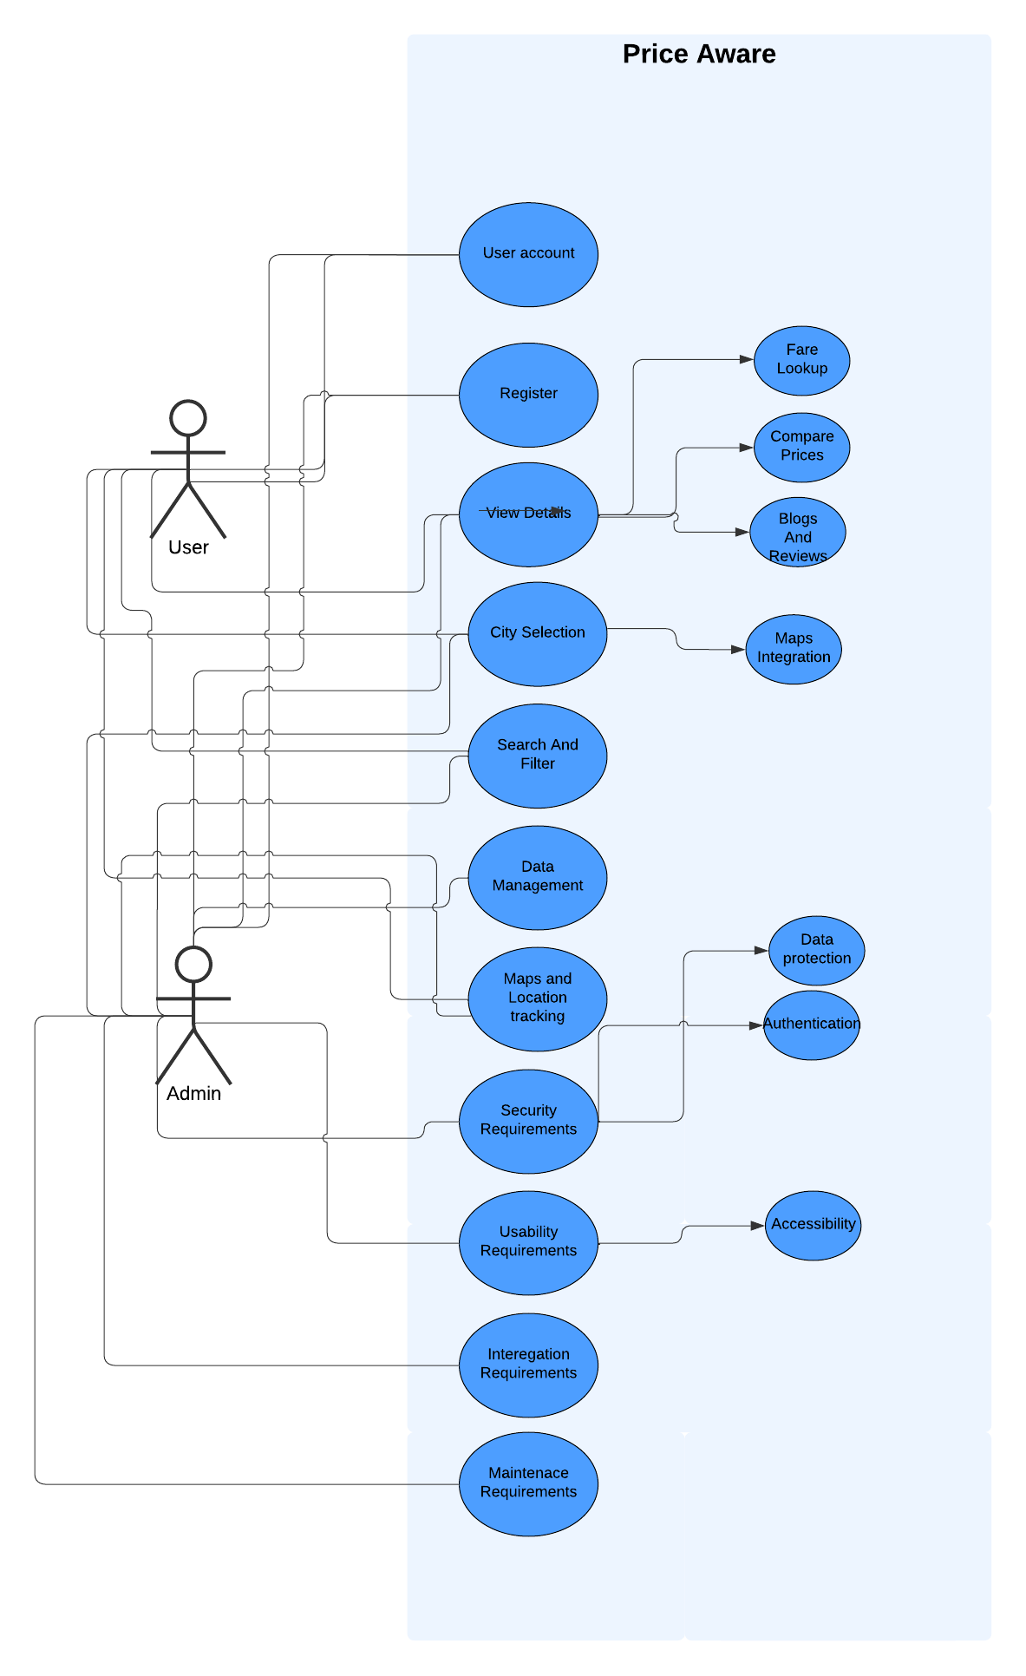

**8. Approval and Sign-off**

**Prepared by:**  
Tejashwini Patil(09)

Shreya Wallalwar (25)

**Approved by:**  
Prof . Sanjay Kalamdhad  
Mentor  
28/8/24